Name: Date: Period:

Read each problem carefully. In order to receive full credit, you must show ALL work.

- Find the distance between the two points. Then, find the midpoint of the line segment connecting the two points. (8, -5) (3, 4)

Graph each equation.
- $y^{2}= 8x$ 3. ${3x}^{2}+ {3y}^{2}=27$

Focus: ______________ Center: ______________
Directrix: ____________ Radius: ______________
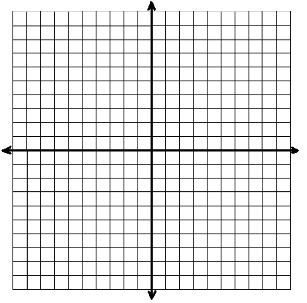

4. $x^{2}+ y^{2}-10x+6y=-18$

Center: ______________

Radius: ______________

5. ${16x}^{2}+ {4y}^{2}=64$ 6. ${\frac{(x+1)}{4}}^{2}+ {\frac{(y-2)}{36}}^{2}=1$
Vertices: ____________________ Vertices: ___________________
Co-vertices: __________________ Co-vertices: _________________
Foci: ________________________ Foci: _______________________

7. $\frac{x^{2}}{25}- \frac{y^{2}}{36}=1$ 8. ${\frac{(y+1)}{16}}^{2}- {\frac{(x-3)}{16}}^{2}=1$
Vertices: _______________ Vertices: _______________
Foci: __________________ Foci: __________________

Write an equation for each conic section.
9. Parabola with a vertex at (0, 0) and a focus and (0, 2). 10. Circle with a center at (5, -7) and radius 4.

11. Ellipse with a center at (2, 4), vertex at (-4, 4) 12. Hyperbola with covertices at (-6, -2) and (-2, -2) and co-vertex at (2, 1). and vertices at (-4, 1) and (-4, -5).

Classify the conic section and write its equation in standard form.
13. ${3x}^{2}+ {3y}^{2}=75$ 14. ${4x}^{2}+ 16y^{2}=64$

15. ${4y}^{2}- {36x}^{2}- 144=0$ 16. 4$x^{2}$ – 16x – y + 21 = 0

17. $y^{2}$ – 6y – 4$x^{2}$ – 8x = 95

18. Solve the following system by graphing. 19. Solve the system of inequalities by graphing.

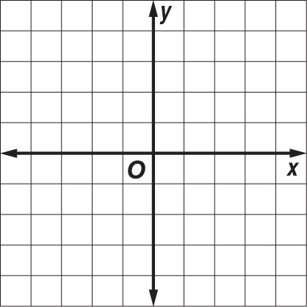
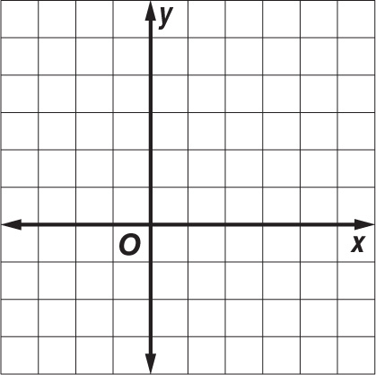
$y^{2}$ = 9 – $x^{2}$ $\frac{x^{2}}{16}$ + $\frac{y^{2}}{4}$ < 1
y = – $\frac{3}{4}$ x + 4
x ≥ 4${(y+2)}^{2}$

20. Find the exact solution(s) of the system of equations algebraically.
$x^{2}$ – 2y = 11
3$x^{2}$ + $y^{2}$ = 24

