9-7 Skills Practice
Solving Linear-Nonlinear Systems

Solve each system of equations algebraically.
1. y = x – 2 2. y = 3x
y = $x^{2}$ – 2 x = $y^{2}$

3. y = x 4. y = 7
$x^{2}$ + $y^{2}$ = 4 $x^{2}$ + $y^{2}$ = 9

5. y = –2x + 2 6. y = 2 – x
$y^{2}$ = 2x y = $x^{2}$ – 4x + 2

7. y = x – 1 8. y = $x^{2}$ + 1
y = $x^{2}$ y = –$x^{2}$ + 3

9. y = 4x 10. 4$x^{2}$ + 9$y^{2}$ = 36
4$x^{2}$ + $y^{2}$ = 20 $x^{2}$ – 9$y^{2}$ = 9

11. 3${(y + 2)}^{2}$ – 4${(x-3)}^{2}$ = 12 12. $y^{2}$ – 4$x^{2}$ = 4
y = –2x + 2 y = 2x

9-7 Skills Practice
Solving Linear-Nonlinear Systems

Solve each system of inequalities by graphing.

1. y ≤ 3x – 2 2. y ≤ x 3. 4$y^{2}$ + 9$x^{2}$ < 144
$x^{2}$ + $y^{2}$ < 16 y ≥ –2$x^{2}$ + 4 $x^{2}$ + 8$y^{2}$ < 16
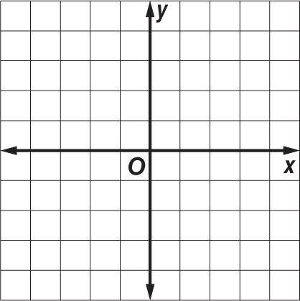

4. y ≥ $x^{2}$ 5. $x^{2}$ + $y^{2}$ < 36 6. $\frac{{(y - 3)}^{2}}{16}$ + $\frac{{(x + 2)}^{2}}{4}$ ≤ 1

y > –x + 2 $x^{2}$ + $y^{2}$ ≥ 16 ${(x+2)}^{2}$ + ${(y-3)}^{2}$ ≤ 4

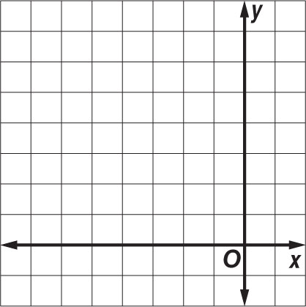
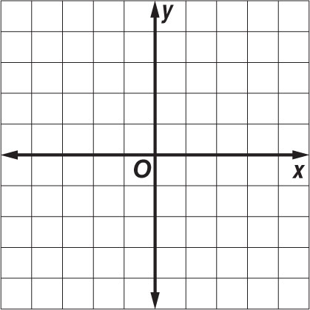
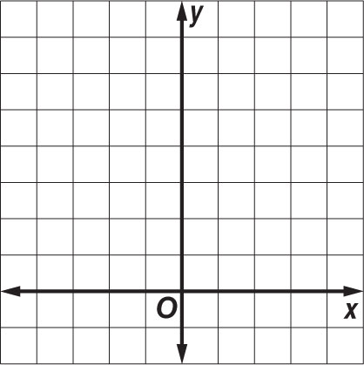

7. GARDENING An elliptical garden bed has a path from point A to point B. If the
bed can be modeled by the equation $x^{2}$ + 3$y^{2}$ = 12 and the path can be modeled by
the line y = – $\frac{1}{3}$x, what are the coordinates of points A and B?

