Algebra 1 Honors
11-2 Practice
Rational Functions

State the excluded value for each function.

1. y = $\frac{-1}{x}$ 2. y = $\frac{3}{x + 5}$ 3. y = $\frac{2x}{x - 5}$

4. y = $\frac{x - 1}{12x + 36}$ 5. y = $\frac{x + 1}{2x + 3}$ 6. y = $\frac{1}{5x - 2}$

Identify the asymptotes of each function. Then graph the function. Identify the domain and range.

7. y = $\frac{1}{x}$ 8. y = $\frac{3}{x}$ 9. y = $\frac{2}{x - 1}$
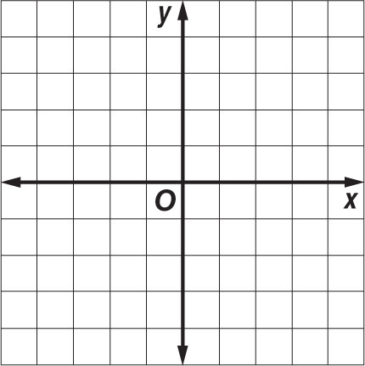

10. y = $\frac{2}{x + 2}$ 11. y = $\frac{1}{x - 3}$ + 2 12. y = $\frac{2}{x + 1}$ – 1

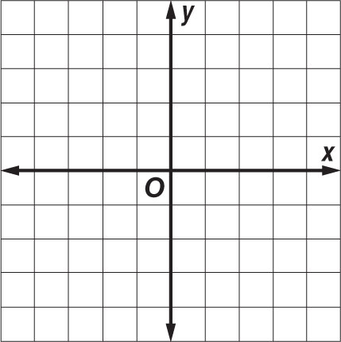

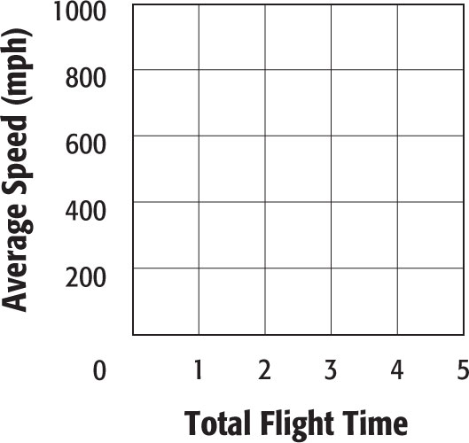
13. AIR TRAVEL Denver, Colorado, is located approximately 1000 miles from Indianapolis, Indiana. The average speed of a plane traveling between the two cities is given by y = $\frac{1000}{x}$, where x is the total flight time. Graph the function.

11-2 Word Problem Practice
Rational Functions

1. BULLET TRAINS The Shinkansen, or Japanese bullet train network, provides high-speed transportation throughout Japan. Trains regularly operate at speeds in excess of 200 kilometers per hour. The average speed of a bullet train traveling between Tokyo and Kyoto is given by y = $\frac{515}{x}$, where x is the total travel time in hours. Graph the function.

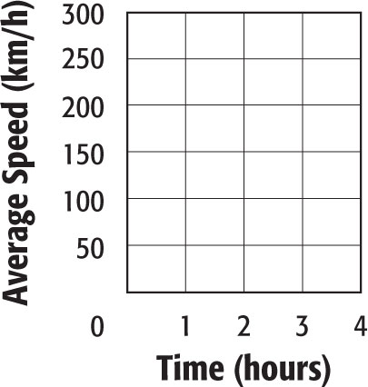

2. DRIVING Peter is driving to his grandparents’ house 40 miles away. During the trip, Peter makes a 30-minute stop for lunch. The average speed of Peter’s trip is given by y = $\frac{40}{x + 0.5}$, where x is the total time spent in the car. What are the asymptotes of the function?

3. ERROR ANALYSIS Nicolas is graphing the equation y = $\frac{20}{x + 3} - 6$ and draws a graph with asymptotes at y = 3 and x = – 6. Explain the error that Nicolas made in his graph.

4. USED CARS While researching cars to purchase online, Ms. Jacobs found that the value of a used car is inversely proportional to the age of the car. The average price of a used car is given by y = $\frac{17,900}{x + 1.2}$ + 100, where x is the age of the car. What are the asymptotes of the function? Explain why x = 0 cannot be an asymptote.

